iCalibrate User Guide

Version 1.0.1

Table of Contents

Revision History 2

Overview 3

Launching 3

Main Window 3

Hall Calibration Dataset Wizard 4

Dataset Display 5

System Administration 5

Source Code 5

Installation 6

Configuration 6

Documentation 6

Figures 7

Figure 1: Menubar File Options 7

Figure 2: Unsaved Data Prompt 7

Figure 3: Choose and Modify Setpoints Dialog 8

Figure 4: New Dataset Wizard 8

Figure 5: Progress Dialog 9

Figure 6: FSD Detected Prompt 9

Figure 7: Dataset Display 10

# Revision History

|  |  |  |  |
| --- | --- | --- | --- |
| **Date** | **Version** | **Description** | **Author** |
| 2016-Oct-25 | 1.0.0 | Initial user guide released | Ryan Slominski |
| 2016-Oct-27 | 1.0.1 | Added path in JMenu and cleaned up typos | Ryan Slominski |

# Overview

The iCalibrate application provides operators a graphical software tool to manage hall ion chamber calibration. The software presents operators with a wizard dialog to guide them through the process of gathering dose rate measurements. Based on options provided by operators the software will ramp the hall laser attenuator incrementally and measure dose rates at the various resulting currents. The software will then use the gathered data to graph a scatter plot with a linear fit to allow quickly determining an appropriate trip setpoint. The data can be saved in a Hall Calibration Dataset (HCD) file to be later recalled if necessary. The ability to apply computed setpoints to the EPICS control system or alternatively to output a SNAP file for future use is also provided.

# Launching

The iCalibrate application can be launched from JMenu by either using the search box with term “iCalibrate” or by directly navigating the menus **Operations** -> **RadCon** -> **IonChambers** -> **iCalibrate**.

# Main Window

The iCalibrate application is document-centric and therefore uses the familiar File menu organization. The file menu includes the following options (Figure 1):

* **New** – Create a new HCD file via the data gathering wizard
* **Open** – Open an existing HCD file
* **Save** – Save a newly created HCD file
* **Close** – Close the open HCD file
* **Export SNAP file** – Create a new SNAP file from the loaded HCD file
* **Export EPICS** – Apply the calculated trip setpoints from the loaded HCD file directly to EPICS
* **Exit** – Exit the application

The save option is only useful after running the wizard to create a new dataset as modifying an existing dataset is not supported. An asterisk is shown in the main window titlebar to indicate that the dataset has not be saved. Further, attempting to close the dataset or exit the application without saving will prompt the user to decide if the data should be saved or discarded (Figure 2). When saving, the suggested filename follows the convention of including the hall, date, target, and pass. HCD files are stored in a configurable, yet known directory so they can be easily found (currently /cs/opshome/IonChambers).

Before exporting to either a SNAP file or EPICS the operator is prompted with the Choose and Modify Stepoint dialog (Figure 3). This dialog allows the operator to choose which ion chambers to include and also provides a means for the operator to manually change the setpoint values.

# Hall Calibration Dataset Wizard

The Hall Calibration Dataset wizard (Figure 4) guides operators through the data gathering process. The first page of the wizard asks for the following:

* **Hall** – Only A, C, and D have Ion Chambers so those are your options
* **Min Attenuator** – The minimum attenuator value (inclusive)
* **Max Attenuator** – The maximum attenuator value (inclusive)
* **# Attenuator Steps** – The number of attenuator steps
* **Step Settle Time (Seconds)** – The number of seconds to wait between attenuator changes for the machine to settle
* **# of Samples Per Step** – The number of samples to take at each attenuator setting to be averaged together for a more accurate measurement

The second page of the wizard automatically detects the laser to use based on the operator’s hall selection using the BOOM Buddy PVs. The target and pass are auto-detected as well, but these fields are user-editable since the detection algorithm may be wrong, and more importantly the values are informational only. The second page also attempts to measure the current to the hall to confirm that beam has been established. The operator can edit the target and pass before continuing, and also can provide an extra note message such as to indicate that a particular hall configuration may affect ion chamber readings (for example variable equipment positioning).

The third and final page is a summary of process parameters for review before starting. The step size that was determined based on number of steps and attenuator range is displayed as well as the estimated duration to complete. Since the attenuator only accepts integers and the attenuator range may not be evenly divisible by the step size the last step size may be slightly smaller or larger to ensure the max value is reached precisely. Since the operator is required to determine the proper attenuator and step values we want to keep the arithmetic as simple as step size = round{range / # steps}. However, due to the min and max attenuator being inclusive (closed interval), we must have an implied extra step, step 0, which is where the attenuator is set to the minimum value. Without this implied step 0 the operator would need to use the following slightly less friendly formula to determine step size: round{range / (# steps - 1)}. The *Start* button begins the process, the *Cancel* button aborts the process, and the *Previous* button allows the operator to return to a previous wizard page to change their selection.

Once the operator clicks the *Start* button and the process begins a progress dialog is shown (Figure 5). The progress dialog has a progress bar which shows the percent complete. The dialog also indicates which step is being performed, which sample is being taken of the given step, and also what state the process is in. If an FSD trip is detected during the data gathering process the operator is prompted with a dialog to either restart the most recent step over again or abort all together (Figure 6). The process states are:

* **SETTLING** – Waiting for the machine to settle after an attenuator change was made
* **DWELLING** – Waiting the 1 second between samples (1Hz scan rate)
* **SAMPLING** – CA-GET on dose rate
* **ADJUSTING** – CA-PUT on attenuator
* **READING** – CA-GET on current after settling
* **WAITING_ON_FSD** – Waiting for operator to choose OK or Cancel

Generally SAMPLING, ADJUSTING, and READING occur so quickly that users will not see them. An exception to this is if there is a problem and the channel access request takes longer than usual.

# Dataset Display

After the dataset wizard has run or after the operator has opened an existing dataset file the dataset display is presented in the main window (Figure 7). There are four panels of information in the display:

* **Dataset Properties** – The metadata associated with the dataset such as hall, target, and pass.
* **Trip Setpoints** – For each ion chamber the existing setpoint is displayed along with the calculated one. Each ion chamber has its own row in a table and the rows are selectable (click on a row to select it). The selected row determines which ion chamber is displayed in the chart below.
* **Calculation Parameters** – The beam current and margin are displayed and can be modified here and result in the calculated setpoint and linear fit being updated in real-time. For each of the two parameters there are both a spinner and a slider provided and they are linked together so changing one changes the other.
* **Fit and Data** – A chart is displayed in this panel showing a scatter plot of the measured data along with a linear fit and calculated setpoint. The raw data is also displayed in a table beside the chart.

# System Administration

## Source Code

The iCalibrate Java Swing application repository is named *icalibrate* and is stored in the git repository on devl00. It can be accessed by members of the JLab accelerator group *epics* from an accelerator Linux machine with the command:

git clone ssh://devl00/usr/devsite/git/icalibrate.git

To switch to a particular version jump to the version-tag with a command like:

git checkout Release1.0

List all tags (versions) with the command:

git tag

Return back to most recent / end of main integration branch:

git checkout master

## Installation

The iCalibrate Java Swing application is distributed as an executable jar file plus its dependencies: configuration and libraries. It is accessible from JMenu. It is currently installed at */cs/opshome/IonChambers/icalibrate*.

An Apache Ant build file (build.xml) is used to compile and package the application. Set your working directory to the icalibrate directory that you obtained from git and execute the following command to build the distributable package:

ant dist

The icalibrate/dist directory contains everything you need to run. You can copy this directory to wherever you want it. The script named icalibrate.sh can be used to launch the application (you may have to chmod +x *.sh). You can also use debug-icalibrate.sh to have logging to the console enabled (edit config/debug-logging.properties to have it go to a file instead).

## Configuration

You can configure several application properties in the configuration file located at icalibrate/dist/config/icalibrate.properites:

* DEFAULT_HCD_FILE_DIR=/usr/opsuser/mccops/IonChambers (alias for /cs/opshome/IonChambers)
* WRITE_ALLOWED=true (set to false for debugging)
* MASTER_FSD_VOLTAGE_PV=ISD0I011G
* Plus dozens more… (read comments in the file for more information)

The epics configuration file located at icalibrate/dist/config/epics.properites allows users to set the EPICS_ADDR_LIST variable directly, but by default the environment variable is consulted.

## Documentation

You can build the JavaDoc API docs with the following command:

ant doc

The generated JavaDoc will be in dist/Javadoc. The other documentation (User Guide, release notes) are located in the dist/doc directory.

# Figures

## Figure 1: Menubar File Options

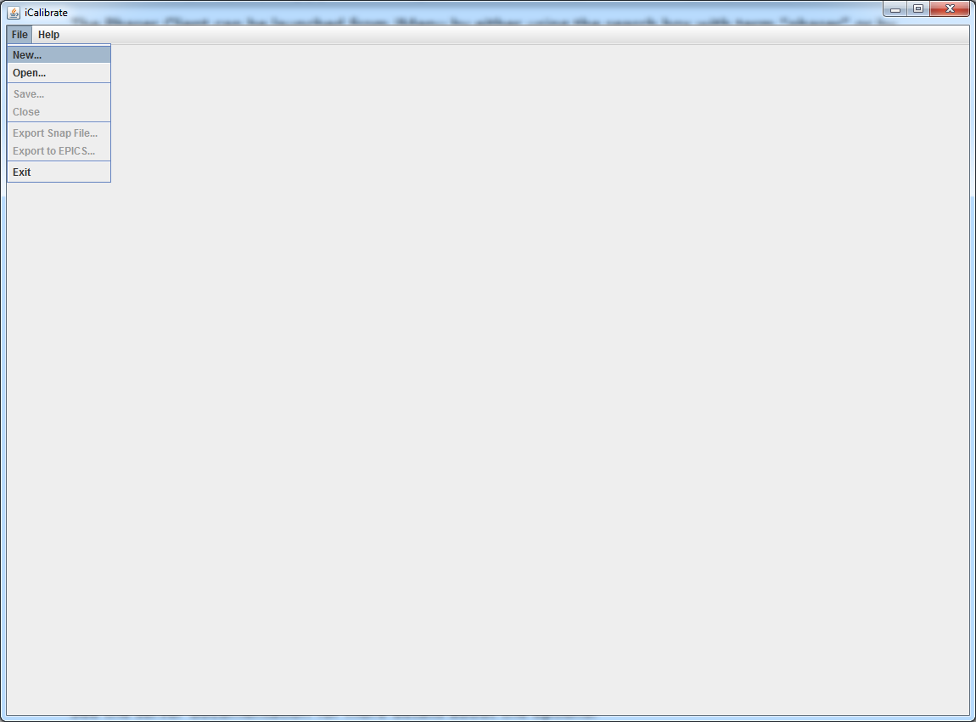

## Figure 2: Unsaved Data Prompt

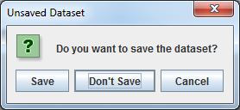

## Figure 3: Choose and Modify Setpoints Dialog

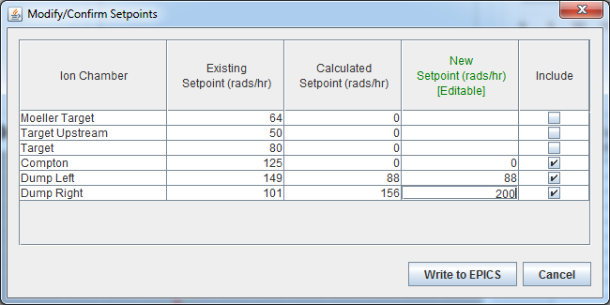

## Figure 4: New Dataset Wizard

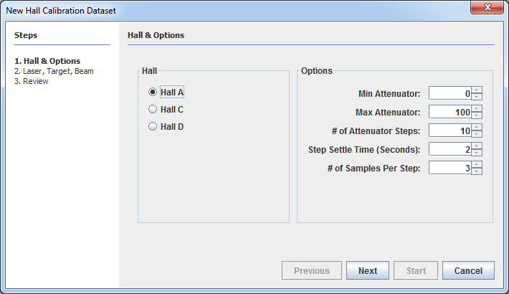

## Figure 5: Progress Dialog

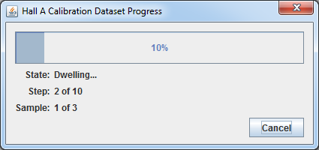

## Figure 6: FSD Detected Prompt

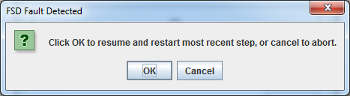

## Figure 7: Dataset Display

